T Account / Balance Sheet Free Response Questions

1.
The Bank of Uchenna has the following balance sheet.
Assume that the reserve requirement ratio is 20 percent.
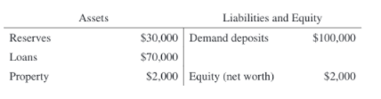
- Calculate the dollar value of the reserves that the Bank of Uchenna is required to hold.
- Given the current reserves, calculate the maximum value of additional loans that the Bank of Uchenna can make.
- Assume that Elike raises $5,000 in cash from a yard sale and deposits the cash in his checking account at the Bank of Uchenna. By how much does the money supply immediately change as a result of Elike’s deposit?
- Calculate the maximum change in demand deposits in the banking system as a whole resulting from Elike’s deposit.
- If the Bank of Uchenna is not meeting its reserve requirement, what action can it take to meet the reserve requirement without calling in loans or selling property?

2
The central bank buys $10,000 worth of bonds in the open market from Elaine, who deposits the proceeds in her checking account at MSM Bank. The required reserve ratio is 5%
- What is the amount by which MSM Bank’s liabilities have changed? Explain.
- Calculate the change in required reserves for MSM Bank. Show your work.
- What is the dollar value of the maximum amount of new loans MSM Bank can initially make as a result of Elaine’s deposit? Explain.
- Based on the central bank’s open-market purchase of bonds, calculate the maximum amount by which the money supply can change throughout the banking system. Show your work.
- How will the change in the money supply in part (d) affect aggregate demand and the price level in the short run? Explain.

3.
Simon opens a new checking account and deposits $8,000 in cash in JCM Bank. The required reserve ratio is 10 percent.

a) Draw a correctly labeled balance sheet (T-account) for JCM Bank and show the numerical value of each of the following as a result of this deposit before any loans have been made.
• (i) Change in Required Reserves (RR)
• (ii) Change in Excess Reserves (ER)
• (iii) Change in Demand Deposits (DD)
(b) What is the maximum amount of loans that JCM Bank can initially make from Simon’s deposit? Provide a numerical value.
(c) As a result of Simon’s deposit, calculate the maximum amount by which the money supply will increase throughout the banking system. Show your work.
(d) In general, how will an increase in the money supply affect unemployment in the short run? Explain.

4
Janet Smith deposits $1,000 of her cash holdings in her checking account at First Federal Bank. The reserve requirement is 20 percent and the bank has no excess reserves.
- What is the immediate effect of her deposit on the money supply? Explain why.
- What is the maximum amount of money First Federal can initially loan out? Explain how you determined this amount.
- What is the maximum amount of money the entire banking system can create? Explain how you determined this amount.
- Give one reason why the money supply may not increase by the amount you identified in (c).

Answers

1
Answers:
- One point is earned for calculating the required reserves: $20,000.
- One point is earned for calculating the maximum amount of additional loans that Bank of Uchenna can make as $10,000 (=$30,000 - $20,000).
- One point is earned for stating that there will be no change in the money supply.
- One point is earned for stating that the maximum change in demand deposits in the banking system is $25,000 (= $5,000 x 5).
- One point is earned for stating that Bank of Uchenna can borrow from other banks to meet its reserve requirements or borrow from the central bank.

2
Answers:
a
The response states that MSM Bank’s liabilities increased by $10,000 and explains that checking accounts are demand deposits, which are liabilities to commercial banks.
b
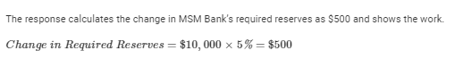
c
The response states that the dollar value of the maximum amount of new loans MSM Bank can initially make is $9,500 and explains that MSM Bank can lend out its excess reserves, which are $9,500 (
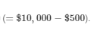
d
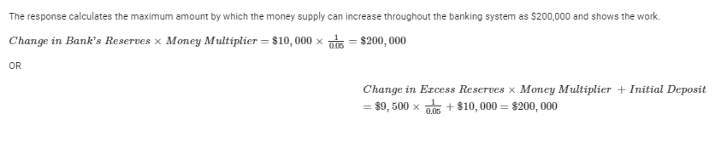
e
The response states that aggregate demand and the price level will increase and explains that the increase in the money supply will result in a decrease in nominal interest rates, an increase in interest-sensitive spending, an increase in aggregate demand, and an increase in the price level.

3
Answers:
a
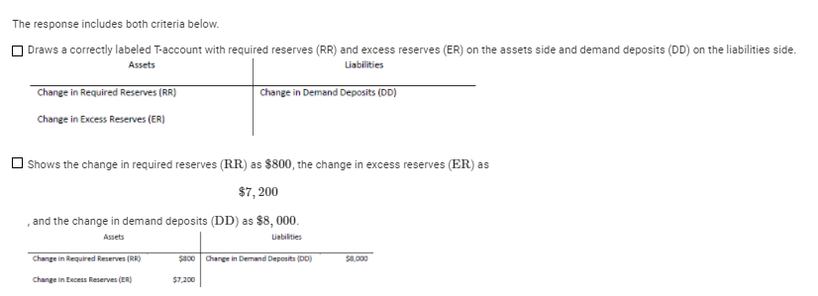
b
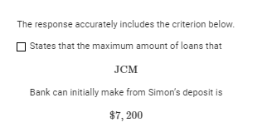
c
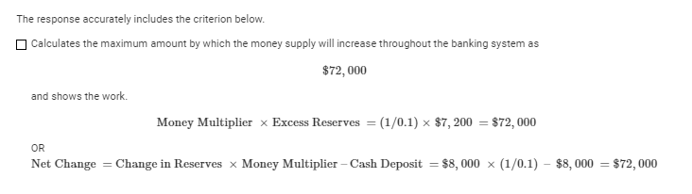
d
States that the unemployment rate will decrease in the short run and explains that an increase in the money supply will decrease the equilibrium nominal interest rate, which will increase interest-sensitive spending, increase aggregate demand, and increase real output.

4
Answers
a
• 1 point No immediate change in the money supply
• 1 point Currency falls but demand deposits increase (M= ↓C+ ↑D)
b
• 1 point $800
• 1 point 1000 – 200 of required reserves = 800 (where 200 = 1000 x 0.20)
c
• 1 point $4,000
• 1 point $4000 found by: $1000 x 5 and then subtract the $1000 that was already part of the money supply: $5000-1000 = $4000
or $4000 found by multiplying $800 x 5
(where 5 = Money multiplier = 1/ rr = 1/ 0.2)
• Alternate explanation worth 1 point: $5000 found by $1000 x 5
d
Possible answers:
• the public holding cash and not redepositing funds in banks
• banks are unwilling to loan out all excess reserves (voluntary excess reserves)
• the public is unwilling to demand loans (insufficient loan demand)
Not acceptable:
• A change in reserve requirements (because this would change the maximum amount that can be lent out, but not the ability for the banking system to lend all that money)

